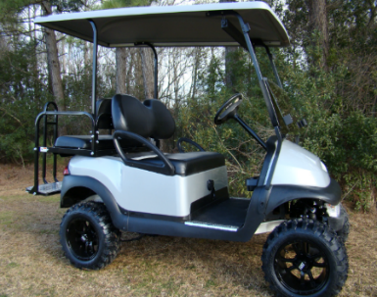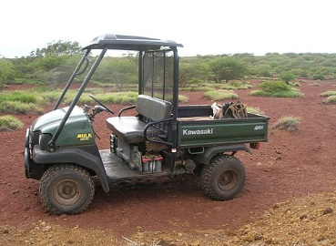
This Photo by Unknown Author is licensed under CC BY-NC-ND
This Photo by Unknown Author is licensed under CC BY-SA
Transportation Golf Cart Policy - Lake Carl Blackwell - July 2022
1. Golf carts or properly road-licensed and tagged side-by-side vehicles are allowed at Lake Carl Blackwell (LCB). These golf carts must display a valid Lake Carl Blackwell Annual User permit. The permit will be affixed to the right rear corner of the golf cart. Any golf cart not displaying a valid Lake Carl Blackwell Annual User permit may be towed without warning. No 4x4 vehicles or dirt bikes will be allowed at LCB.
2. No one is allowed to operate a golf cart at any time unless they possess a valid Driver's License. In addition, all persons must ride in a designated golf cart seat and be seated.
Children are not allowed to drive golf carts at LCB, even in the presence of a parent/adult.
3. Golf carts used after legal sunset and before legal sunrise shall be equipped and operated with working headlights, signal lights, and taillights. If a golf cart is not equipped with headlights, signal lights, and taillights, it cannot be operated when headlights and taillights would be required on a public roadway. Golf cart operators should use hand signals for turning signals during daylight hours. Failure to signal any turn is a moving violation and may result in a ticket and fine.
4. Golf carts shall be operated at speeds no greater than all safety concerns demand. Always consider the terrain, weather conditions, and existing pedestrian and vehicular traffic, which may affect your ability to operate the golf cart safely.
5. Golf carts must not impede or interfere with normal pedestrian or vehicular traffic, boat ramps, or roadways. Golf carts are not allowed on any sidewalks.
6. Golf carts shall not be parked: A: in DMV Accessible parking spaces, B: in reserved parking spaces, C: within 10 feet of any doorway, including cabins, trailers, and vehicles, and D: in a manner that would impede the normal flow of pedestrian traffic.
7. Golf carts shall be equipped with a "Slow Moving Vehicle" sign.
8. Golf carts shall not be modified in any manner that affects the golf cart's recommended mode of operation, speed, or safety.
9. Accidents involving a golf cart shall be reported immediately to the OSU POLICE DEPARTMENT at (405) 744-6523. Failure to report an accident may result in suspending any permit previously issued.
10. Golf carts shall be operated in compliance with the common "rules of the road" regardless of whether they are being operated on service drives or roadways. Golf carts should give the right of way to vehicles behind them when traveling slower than the posted speed limit.
11. Parking citations will be issued for parking violations in reserved or accessible parking spaces. These citations are issued to the vehicle's driver for moving violations or to the registered owner for policy violations. The person to whom the citation is issued is responsible for paying or appealing the citation.
12. Golf carts will only be driven on pavement or gravel and not to be driven through grass or on trails at any time. Golf carts found driving on grass or trails will be removed from the park and no longer allowed back.
13. Golf carts will be operated with the utmost courtesy, care, and consideration for the safety of pedestrians. Pedestrians shall always be given the right of way. Golf carts shall be operated with the utmost care and respect for the Lake Carl Blackwell property.
14. Transportation golf carts may be operated from 7 AM till 10 PM. No golf carts are to be operated after 10 PM.
15. The bottom portion of this policy must be signed by each person who plans to own and/or operate a golf cart on the Lake Carl Blackwell property. All Golf Carts must be permitted and have a signed policy form on file to be allowed on LCB Property.
16. No golf carts are permitted on what is known as Hwy 51C / Lake Carl Blackwell Road. Please drive in the grass if you need to go north or south on this road. Plans are in place for a golf cart/utility lane on the east side of the road this upcoming year.
17. A designated golf cart crossing will be set up at Hwy 51C / Lake Carl Blackwell Road and Campground Road. All golf carts that need to cross Hwy 51C must do so at this location.
I have read the Golf Cart Policy and agree to abide by these requirements.
Name (printed): _____________________________________
Campground: _______________________________________
Site #: ______________________________________________
Date: ______________________________________________
Signed: _____________________________________________

